**The Confederated Tribes of Grand Ronde and Spirit Mountain Community Fund are pleased to announce Pat Daniels, Aldin Porcic and Loretta Cukale as the 2024 yeʔlan lima (Helping Hand) award winners.**

Each year, the Spirit Mountain Community Fund selects three individuals (an unpaid volunteer, a paid staff member, and a paid management member) doing incredible work in the nonprofit sector to receive our annual yeʔlan lima award. (In our Chinook language, yeʔlan lima means Helping Hand.) Each award recipient receives a special award, a free night stay and dinner for two at Spirit Mountain Casino, and $500 for their outstanding efforts to helping those in need.

**Paid Management**: Pat Daniels ~ Constructing Hope

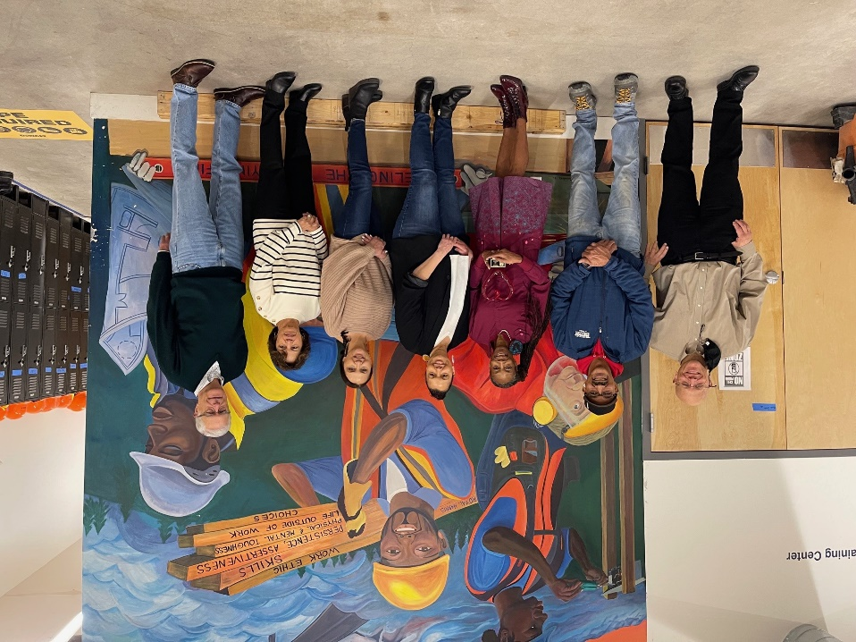

**Paid Non-Management**: Aldin Porcic ~ Community Transitional School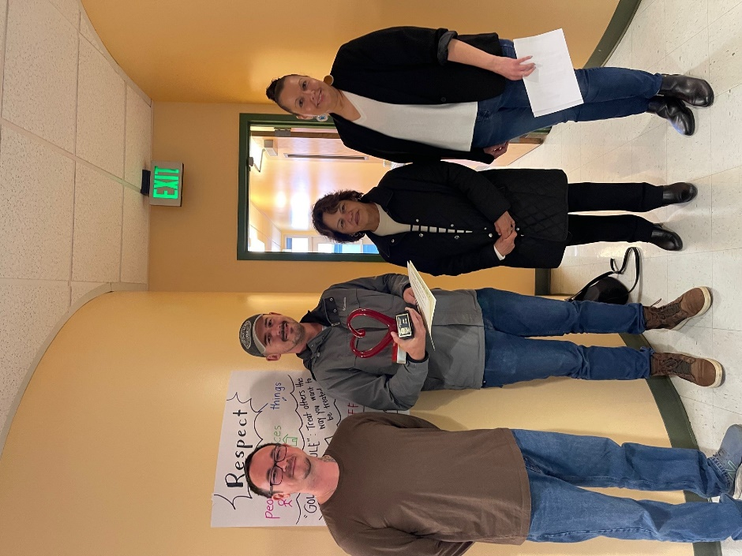

**Non-Paid Volunteer**: Loretta Cukale ~ Dougy Center

